**Primary key 제약**

1. **Create Table sample633(**

**A integer primary key,**

**B integer);**

1. **Desc sample633;**
2. **Insert into sample633 values(1,1);**
3. **Insert into sample633 values(null,null);**
4. **Insert into sample633 values(1,null);**

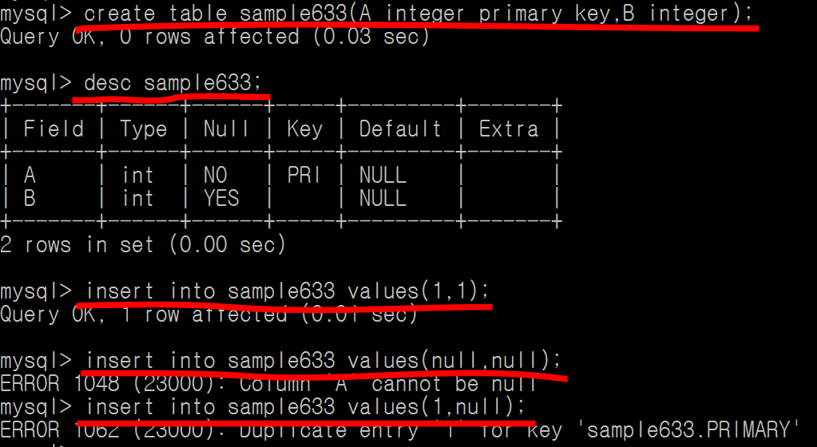

**Primary key 제약 🡪 not null + unique**